Description of Psychophysics Software Suite
Dr. Karen Banai ( kbanai@research.haifa.ac.il )

Background
Our goal is to assess the resolution (that is the minimal difference between tones a listener can detect) of the auditory system along various acoustic parameters (e.g., intensity, frequency). To that end we want a 'platform' that will let us present our listeners with a series of sounds that are defined based on their acoustic parameters, ask them a question (e.g., were all the sounds the same, or which sound was different from the others), record their response (using a mouse/response box), adapt the sounds based on their response and continue the experiment until sufficient data was collected. We would like you to use Matlab for the programming. In what follows our requirements are described first generally and than with details about the required modules.

General description of the required software
The key features of the program should be (1) Sounds are presented adaptively: The auditory stimuli to be presented on a given trial are determined based on the performance of the listener on the previous trial. (2) Flexibility in the definition of the adaptive parameter: We want to be able to adapt a verity of acoustic parameters that can be defined mathematically (e.g., frequency, duration, AM, FM, duration of gap in noise or between noise and tone). (3) Precision: the sounds generated should be accurate to the level of 1/1000 sec in timing and 1 Hz in frequency. We should also have the means to control the volume. (4) Flexibility in the choice of standard psychophysical procedures (e.g., ABX, AXB etc') and the ability to add new procedures in the future. (5) The interface presenting the stimuli to and collecting the responses from the listener should be child friendly. We want each instance of sound to be marked by a graphic, as well as some other features that will make the task more engaging for young children (see Figure 1 for en example). (6) The program should provide the experimenter with feedback every block of trials and also save all the data for 'off-line' analysis.
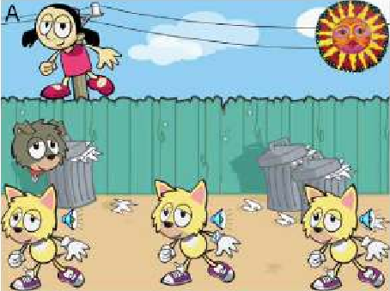
Figure 1. Example of an ‘oddball’ task in a child friendly interface (Moore et al.,2007).
In this experiment, each cat seems to make a sound (open and close its mouth) and then raises its hands to mark that they are done. Each time a cat makes a sound, the dog lifts an ear to mark that the sound is being played and the child should listen. With every trial the girl moves one step closer to the sun. The children are told that their task is to make the girls reach the sun. This program was written in Visual Basic and examples of ‘task files’ generated by the experimenter to control what is being tested in a given instance are available.
The general idea is that several stimuli (>2) are presented on each trial. The child makes a response based on the task s/he is asked to perform (e.g., if 3 stimuli are presented we may ask the child whether the 2nd or the 3rd was identical to the first, or in a child friendly language – if the stimuli are represented by a dog, a cat and a mouse, we may ask whether the cat or the mouse made the same sound as the dog; or we may want to simply ask which animal made the sound that was not like the others) and receives feedback. The stimuli for the next trial are chosen based on whether a correct or an incorrect response was given. The experiment continues until a certain number of trials were completed or until a certain number of reversals in the adaptive track have occurred (see Figure 2).
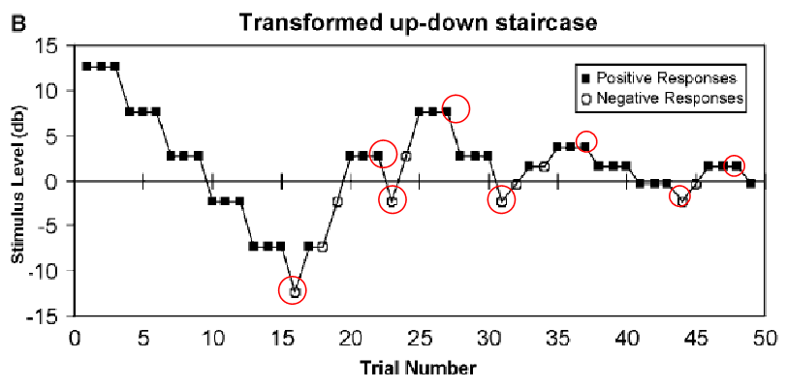
Figure 2. Example of a 3 down/ 1 up staircase procedure. Following 3 consecutive correct responses, the stimuli are made harder to discriminate. Following a single error the stimuli are made easier to discriminate. The trials marked with red circles are called reversals – trials in which the direction of the staircase changes from descending to ascending or vice versa. Description of the major components (or modules) of the required ‘software’

Note that if the program is modular and easy to follow, we will be able to add to each module in the future based on what we find during the pilot phase of the experiment. The following components need to be linked into functional tests or experiments:
I. Stimuli
Stimuli are non-verbal sounds that can be defined based on an equation with parameters such as time, modulation depth etc' determined by the experimenters (e.g., pure tones, AM tones, FM tones, white noise, narrow/broad band noises etc’). The program will adapt the stimuli according to the parameter defined by the experimenter (e.g., adapt frequency and keep every other parameter constant or adapt modulation depth and keep everything else constant). The parameters we are interested in are: duration (with a resolution of 0.001 sec), frequency (resolution of 1 Hz), modulation depth, modulation rate, gap in noise or between noise and tone, intensity. In addition the experimenter should have control on the duration of each stimulus and the interval in between the stimuli (ISI). Stimulus durations can vary from 10 ms to 2 s. ISI usually varies between 0 and 10 seconds, depending on the task. Alternatively ISI is randomly selected from an interval (e.g., 100 ± 25 ms). The non-adaptive parameters are defined by the experimenter before the experiment and are then fixed within a block of trials or a ‘run’. All stimuli should be ramped with a x ms onset/offset cosine^2 ramp to avoid annoying clicks when the sound is being played.
II. Stimulus anchoring mode
Fixed reference vs. roving mode: it should be possible to run each task either by defining a fixed reference (e.g. F = 1000 Hz) and choosing the other stimuli accordingly (e.g., only higher, only lower or either higher or lower) or without a reference where on each trial the "reference" is selected at random from an interval (e.g., 700 – 1300 Hz) and the other stimulus is selected accordingly (again it can be in this case only higher, only lower or either higher or lower).
III. Behavioral tasks
The program should allow the experimenter to implement a variety of standard psychophysical procedures which define exactly what the listener has to do with the stimuli they hear. It should also let us add new procedures in the future should the need arise. The general idea is that on every trial the listener is asked to respond to one test tone that is different in some aspect from the other tone(s) presented sequentially on that trial. What kind of response they have to make, depends on the experiment. For example, in an 'oddball' task (see Figure 1) we simply ask which of n (3, 4, 5…n) tones was different from all the others. In an identification task we may ask the subject something like which of two tones was higher the first, or the second or which of 3 tones was the shortest the second or the third). In an XAB task, we ask whether A or B were the same as X. X is fixed on every trial and whether A or B is identical gets randomly selected on every trial. Based on the subjects reply, the test tone (A or B) gets more or less similar to X. Similarly, we can have multiple X's to run an XXXXAB task. The acoustic difference between the test and the reference(s) tone(s) is adapted on a trial by trial basis according to the listener's response. This is the part of the program where we want the to have the greatest flexibility because one goal of our study is to determine which of multiple possible methods works best in several age groups and clinical conditions. Once the project begins a full list of required tasks will be provided.
Example of a task: XAB: 3 tones are presented on each trial X (the reference tone), A and B, A or B is the same as X and the other one is different. The task is to decide whether A or B was identical to X. If the listener answers correctly, on the next trial the tone that is different from X becomes more similar (based on the adaptive procedure). In this task, X stays the same through out the experiment and reversals are determined based on the value of the tone (A or B) that is not the same as X. so here if there are 3 "figures" making the sounds one representing X, one A and one B, the child should respond by clicking on the appropriate A or B figure.
IV. Adaptive procedure
The adaptive procedure determines how stimuli are changed from trial to trial based on the response given by the listener on the previous trials. Typically this is done using some variation on the "staircase procedure" shown in Figure 2, in which the difference between the stimuli is decreased following x correct responses and increased following y incorrect responses. This is termed x down/y up staircase and the experimenter chooses x and y ahead of time.
V. Adaptive rules
The adaptive rule defines how the stimuli change from trial to trial (or how the difference between stimuli in a trial is adapted based on the listener’s response). In general, stimuli change in ‘steps’ and the experimenter should be able to decide how many kind of steps there are (e.g., large, intermediate and small), what is the step size for each kind of step (e.g., 50% for large steps, 10% for intermediate and 1% for small), when does the shift between kinds of steps occur and what is the initial, minimal and maximal difference allowed between stimuli in the trial, and the mode in which stimuli change (additive, multiplicative).
Additive step – following an error Δ is increased by a specified amount; following x correct responses Δ is decreased by a specified amount.
Multiplicative steps - Δ is multiplied/ divided by some constant.
In addition we want to be able to determine how many steps there are and when they will change. For example, we may decide that we want initially to change Δ by 50 Hz and after 3 reversals to change Δ by 30 Hz and after 3 additional reversals by 20 Hz.
Finally we need control over how long the experiment keeps running. Usually we want to terminate the experiment after a certain number of trials (e.g., 60), a certain number of reversals with the smallest step size (e.g., 7), a certain number of total reversals (e.g., 16) or a combination of number of trials and reversals.
VI. Listener’s response mode
Listeners or the experimenter will select their response by clicking the appropriate 'graphic' on the screen or touching the screen in case we get a touch screen. Option: also let the listener self pace the experiment by clicking a separate graphic to continue to the next trial.

VII. Listener’s interface
We want to embed the procedure in a child friendly "computer game". Important points are: (1) that the presentation of every sound is marked by a visual event (e.g. a cartoon that opens its mouth when the corresponding sound is being played) telling the subject that a sound is being played (though not of course whether that was the test or not). (2) There should be positive feedback following each correct response (e.g., a happy smiley). (3) There should be some kind of a graphic 'meter' on the screen telling the subjects how long they still have to go.
Option: if cartoons are used, have a variety so children can select their favorite.

VIII. Experimenter’s interface
We want to be able to define experiments (e.g., frequency discrimination in an oddball procedure with additive step, x trials and y reversals) ahead of time and save them to an input file (e.g., a text file). During the experiment we want the experimenter to load the input file, enter the listener's code and run the experiment. In the end of the experiment we want the program to calculate and present the discrimination threshold on the screen and save all the data from the block to a data file for further analysis. We also want to give the experimenter the option to 'sequence' several tasks or blocks to run one after the other without their interference.

IX. Saved data/Data files
We want to save the information on any given trial (what the stimuli were, what was the response, whether it was correct, RT and whether the trial was a reversal or not).
We also want to save the subjects code, the date and time the experiment was run, the input parameters (what were the experiment, adaptive parameter, type of task and the rest of the predefined parameters), and the threshold and measure of variability calculated from the reversals (see below).

X. Threshold calculation mode
Defines which reversals are counted for threshold calculation and how the threshold is calculated. For example, we can choose to calculate thresholds based on all the reversals occurring after the “small” step was initiated or based on all the reversals but those occurring with “large” steps. Threshold can then be calculated as the mean, the geometric mean or the median of the selected reversals. A corresponding measure of variability is also calculated (SD of the reversals in case of a mean, IQR in case of a median).

